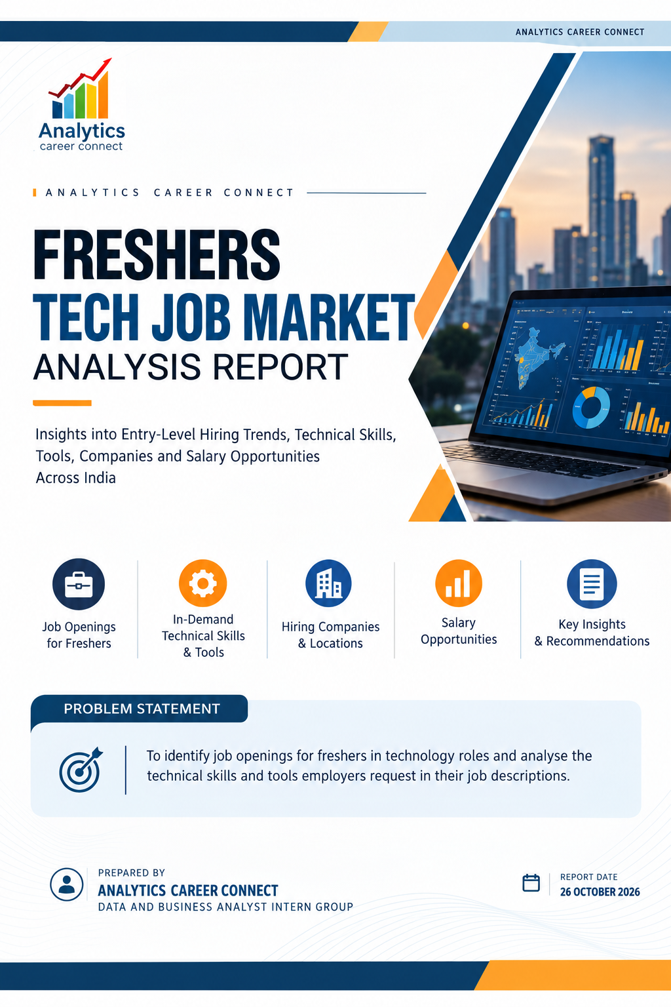
Table of Contents
Section | Contents | Page
1 | Executive Summary | 3
2 | Introduction | 4
2.1 | Importance of Tech Job Market Analysis | 4
2.2 | Objectives of the Dashboard | 4
2.3 | Scope of Analysis | 5
2.4 | Data Sources & Methodology | 5
2.5 | Why the Dashboard Was Developed | 5
2.6 | Key Business Questions It Answers | 5
3 | Dashboard Overview | 6
3.1 | Dashboard Objectives | 6
3.2 | Dashboard Components | 6
4 | Tech Job Market Overview Analysis | 7
4.1 | Overall Fresher Tech Job Market | 7
4.2 | City-wise Hiring Analysis | 7
4.3 | Industry Analysis | 8
4.4 | Job Role Analysis | 9
4.5 | Work Mode Analysis | 9
4.6 | Experience Distribution | 10
5 | Tech Skills & Career Analysis | 11
5.1 | Technical Skills Analysis | 11
5.2 | Development & Data Skills Analysis | 11
5.3 | Tools Analysis | 12
5.4 | Department Analysis | 12
5.5 | Fresher Hiring & Experience Expectations | 13
5.6 | Employer and Source Platform Analysis | 13
6 | Salary Analysis | 15
6.1 | Salary Overview | 15
6.2 | Salary Range / Role-wise Salary Distribution | 15
6.3 | Salary by Experience | 15
6.4 | Salary by City | 15
6.5 | Highest-Paying Tech Roles | 16
6.6 | Salary by Job Role and Career Path | 16
7 | Key Business & Career Insights | 17
8 | Recommendations | 17
8.1 | For Students / Freshers | 17
8.2 | For Training Institutions | 17
8.3 | For ACC | 17
9 | Conclusion | 18
Appendix | Data Notes & Caveats | 19

1. Executive Summary
The Freshers Tech Job Market Analysis Dashboard provides a structured view of entry-level technology hiring across India. The dashboard contains 11,781 job postings from 5,538 hiring companies across 324 cities. It reports 2,134 job-role labels, 91 hiring-state values and an average advertised salary of 7.43 LPA. The analysis focuses on which technology roles appear most frequently, where openings are concentrated, what skills and tools employers request, and how salary differs by role, city and experience requirement.
Demand is spread across a large number of employers rather than being controlled by a small group of companies. The top ten listed employers account for approximately 9% of postings. Software Engineer (916) and Full Stack Software Developer (887) lead the top role list, followed by Machine Learning Engineer (805), Data Engineer (687) and Data Analyst (593). AI Engineer and Generative AI Engineer also appear among the ten leading titles, indicating visible demand for AI-oriented capabilities in the fresher dataset.
Location analysis identifies Bengaluru as the largest city in the dashboard, although its value is not directly labelled and is estimated at about 2.0K. Mumbai, Hyderabad and Chennai each have more than 1.1K postings. Maharashtra, Karnataka, Tamil Nadu and Telangana are the leading states. These results suggest that candidates should consider multiple large technology hubs while also checking remote options.
Python and SQL are the most frequently mentioned technical skills, with approximately 9.5K and 7.2K mentions respectively. Git (6.8K) and Docker (5.7K) lead the tools list, followed by GitHub, VS Code and AWS. The dataset also shows demand for REST APIs, Java, data structures and algorithms, OOP, machine learning, ETL/ELT pipelines, data modelling, databases and analytics tools.
The experience chart shows that the largest labelled group is 0–2 years (about 4.6K postings), followed by 1–2 years (3.0K). Strictly zero-experience roles account for about 2.3K postings. This means that a job described as suitable for freshers may still accept or prefer some practical exposure. Projects, internships and demonstrable hands-on work can therefore be important when applying.
The average advertised salary is 7.43 LPA, but the salary figures vary by job title. Generative AI Engineer (9.6 LPA), AI Engineer (9.4 LPA), Machine Learning Engineer (8.9 LPA), Data Scientist (8.8 LPA) and Data Engineer (8.1 LPA) are above the overall average in the supplied dashboard. Data Analyst is shown at 5.9 LPA. Salary values should be interpreted with the dashboard’s data-quality caveats, including the lack of a salary-record count.

Key findings
- 11,781 postings from 5,538 companies across 324 cities.
- Software, data and AI titles feature prominently among the most common roles.
- Python, SQL, Git and Docker are the strongest foundational skill/tool signals.
- On-site is the largest work-mode category (44.97%); hybrid is 31.44% and remote is 23.59%.
- The 0–2 years group is the largest experience category; true fresher postings are a smaller subset.
- The dashboard average advertised salary is 7.43 LPA, with AI and data-specialist roles above that average.

2. Introduction

2.1 Importance of Tech Job Market Analysis
Technology hiring changes with business demand, digital transformation, software development practices, cloud adoption, data-driven decision-making and the growth of artificial intelligence. For students and fresh graduates, understanding job-market patterns helps turn a broad interest in technology into a realistic preparation plan.
A job-market analysis connects job titles with the practical requirements listed by employers. It helps candidates understand which skills recur across postings, which tools are used in everyday workflows, where vacancies are concentrated, what experience levels are accepted and how advertised salaries differ between roles.
The supplied dashboard shows that employers request a mixture of programming fundamentals, databases, APIs, collaboration tools, containers, cloud platforms and specialised data/AI capabilities. Candidates can use these signals to prioritise their learning rather than attempting to learn every technology at once.

2.2 Objectives of the Dashboard
- Measure fresher-oriented technology hiring volume across roles, companies and locations.
- Identify the most frequently listed technology job titles.
- Analyse city and state distribution to identify major hiring hubs.
- Understand the distribution of work modes and stated experience requirements.
- Identify technical skills and tools that recur in job descriptions.
- Review hiring-company types and the platforms through which postings were found.
- Compare available advertised salary indicators by job title, city and experience band.
- Translate dashboard findings into practical recommendations for students, training institutions and ACC.

2.3 Scope of Analysis
The analysis covers the dashboard’s 11,781 job postings and focuses on the three available dashboard pages: Overview; Skills & Tools Employers Ask For; and Companies & Pay. The scope includes job titles, cities, states, industries, work modes, experience requirements, skills, tools, departments, employer types, hiring companies, source platforms and salary summaries.
- Market demand: posting volume and role distribution.
- Geographic distribution: leading cities and states.
- Work arrangements: on-site, hybrid and remote.
- Experience: stated experience categories, including fresher (0 years).
- Skills and tools: most frequently mentioned technical capabilities and software tools.
- Employer landscape: company type, named employers and posting sources.
- Salary: overall average and displayed comparisons by role, city and experience.

2.4 Data Sources & Methodology
The report uses the supplied Power BI dashboard PDF, “Power_Bi_project_dashboard_final.pdf”, as the primary analytical source. Values are transcribed from dashboard cards, charts and labels. Where a visual does not display an exact number, the report explicitly describes the value as an estimate or avoids presenting an unsupported exact value.
The analysis is descriptive. Counts are used to rank job titles, cities, skills, tools and companies. Percentages shown in the dashboard are used to describe work mode and department shares. Salary comparisons are reported in LPA as displayed in the dashboard. The report does not infer causal relationships between a skill and salary.

2.5 Why the Dashboard Was Developed
The dashboard was developed to make a large set of technology job postings easier to interpret. Instead of reviewing postings individually, users can explore summary metrics and compare roles, locations, skills, tools, experience requirements and salary indicators in one place. Filters for job title, city and work mode support focused exploration.

2.6 Key Business Questions It Answers
- Which technology roles have the largest number of fresher-oriented postings?
- Which cities and states contain the most opportunities?
- Which industries and departments account for a substantial share of the visible postings?
- Which technical skills and tools are mentioned most often?
- How much of the market is on-site, hybrid or remote?
- What experience requirements appear in postings labelled for freshers?
- Which employer types and companies appear frequently?
- How does displayed salary vary by role, city and experience band?

3. Dashboard Overview

3.1 Dashboard Objectives
The dashboard is designed to summarise entry-level technology opportunities and allow users to move from overall market indicators to skills and employer details. It provides a compact view of hiring volume, popular roles, locations, work mode, experience requirements, technical skills, tools, departments, company types, source platforms and salary comparisons.

3.2 Dashboard Components
Dashboard page | Main components | Purpose
Overview | Total postings, hiring companies, cities, job roles, states, work modes; top roles, cities, states, industries and experience | Understand the size and shape of the fresher-oriented market.
Skills & Tools | Top technical skills, tools, departments hiring freshers and experience requirement chart | Identify technical learning priorities and role-aligned toolsets.
Companies & Pay | Average salary, employer types, top companies, source platforms, salary by role, city and experience | Compare hiring organisations and salary indicators.
The dashboard includes slicers for job title, city and work mode. These filters can be used to narrow the analysis to a specific role family, location or working arrangement. Any filtered interpretation should be read with the selected filter state in mind.

4. Tech Job Market Overview Analysis

4.1 Overall Fresher Tech Job Market
Dashboard metric | Value
Total job postings | 11,781
Hiring companies | 5,538
Hiring cities | 324
Job-role labels | 2,134
Hiring-state values | 91
Average advertised salary | 7.43 LPA
The number of companies relative to postings indicates a fragmented market: the dashboard contains roughly 2.1 postings per company. The top ten listed companies together contribute around 9% of all postings, so job seekers should not limit their search to a few well-known employers.

4.2 City-wise Hiring Analysis
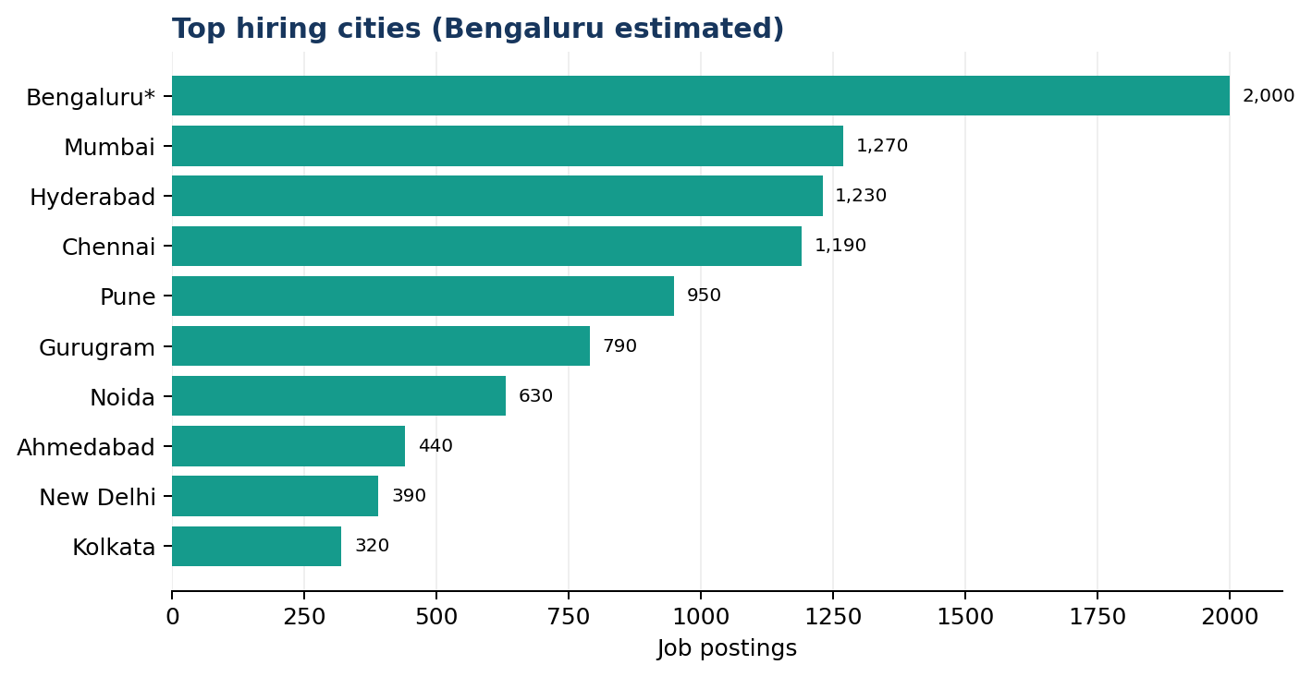
Figure 1. Top hiring cities; Bengaluru is estimated from the dashboard funnel marker.
Bengaluru is the largest hiring city, at approximately 2.0K postings; the dashboard does not print a direct label for this value, so it is an estimate. Mumbai (1.27K), Hyderabad (1.23K) and Chennai (1.19K) form the next tier. Pune is also a notable market at about 0.95K, followed by Gurugram at 0.79K. The ten cities displayed account for approximately 78% of postings.
These results indicate that candidates should monitor openings across several large cities instead of relying on one location. Pune appears among the leading cities, while Gurugram combines fewer postings than the largest metros with the highest displayed city-level average salary.

4.3 State-wise Hiring Analysis
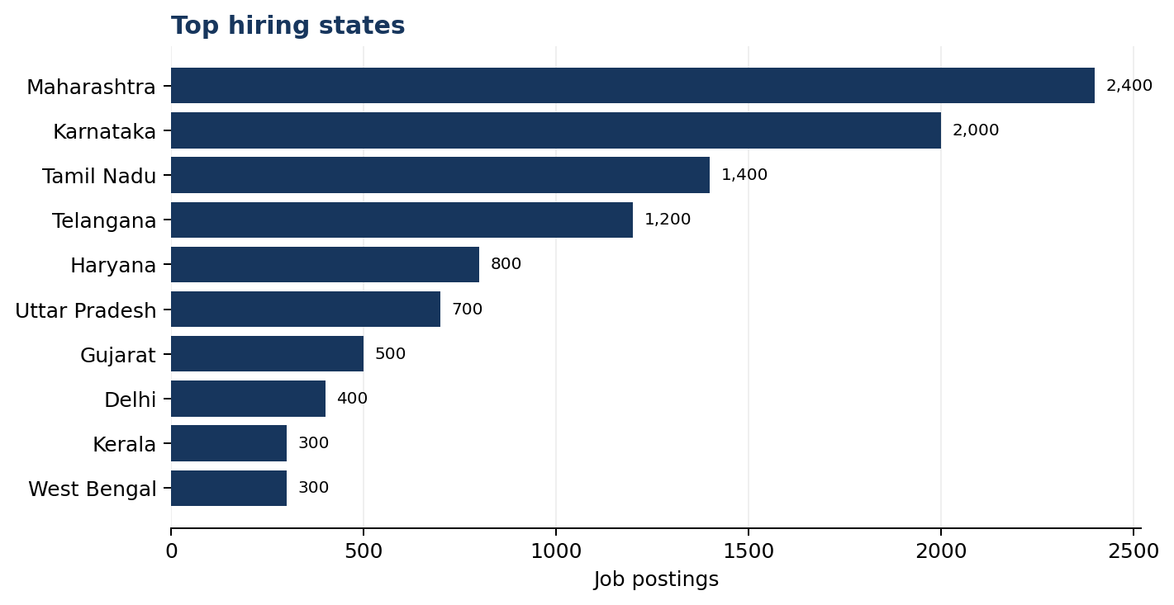
Figure 2. Top hiring states; values are rounded from dashboard labels.
Maharashtra leads the state chart at about 2.4K postings, followed by Karnataka (2.0K), Tamil Nadu (1.4K) and Telangana (1.2K). Haryana is next at about 0.8K. The four leading states account for a substantial portion of the market shown in the dashboard. The reported count of 91 hiring-state values is inconsistent with the number of Indian states and union territories, so location standardisation is recommended before using this field for formal reporting.

4.4 Industry Analysis
Industry shown | Postings (approx.) | Share of total (approx.)
IT Services & Consulting | 4.51K | 38%
FinTech & Digital Payments | 2.27K | 19%
Data Analytics & AI Services | 1.25K | 11%
Software Products | 0.94K | 8%
EdTech | 0.41K | 3.5%
Data analytics label (truncated) | 0.38K | 3.2%
IT Services & Consulting is the largest industry category. FinTech & Digital Payments is second, followed by Data Analytics & AI Services and Software Products. The treemap includes smaller Artificial Intelligence and Banking/Finance categories, but readable values are not available for all tiles. Those categories are therefore not assigned exact counts in this report.

4.5 Job Role Analysis
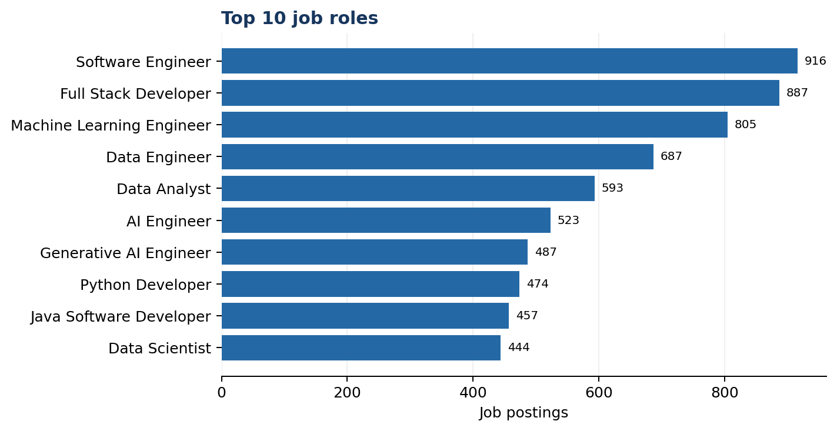
Figure 3. Top 10 job roles by posting count.
Software Engineer (916) and Full Stack Software Developer (887) are the two largest titles. Machine Learning Engineer (805), Data Engineer (687) and Data Analyst (593) follow. AI Engineer (523) and Generative AI Engineer (487) also rank among the top ten, ahead of Python Developer (474) and Java Software Developer (457). Data Scientist has 444 postings.
The top ten role labels cover about 6.3K postings, roughly 53% of the dataset. The variety of titles suggests that candidates should search using multiple related title variants, especially within software development, data engineering, analytics and AI.

4.6 Work Mode Analysis
Work mode | Share | Approximate postings
On-site | 44.97% | 5.3K
Hybrid | 31.44% | 3.7K
Remote | 23.59% | 2.8K
On-site is the most common work arrangement, followed by hybrid and remote. Remote postings account for nearly one quarter of the visible distribution, so remote-first filters can be useful, although competition and eligibility may vary by role and employer.

4.7 Experience Distribution
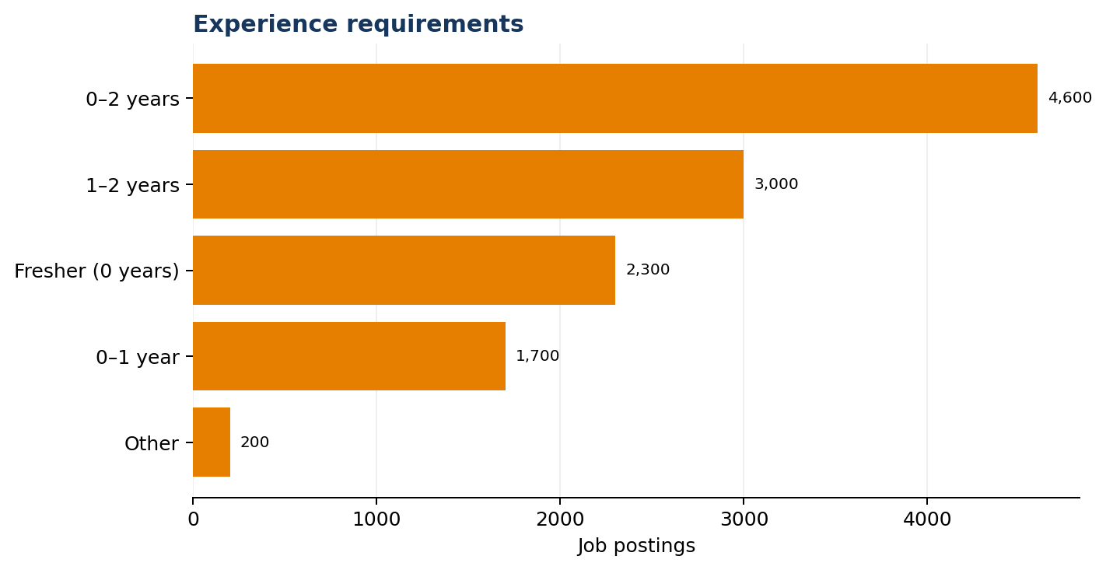
Figure 4. Experience requirements shown in the dashboard.
The largest category is 0–2 years at about 4.6K postings, followed by 1–2 years at 3.0K, Fresher (0 years) at 2.3K and 0–1 year at 1.7K. These labels overlap rather than forming mutually exclusive ranges, so the counts should not be added together as unique postings. The key takeaway is that strict zero-experience roles are a smaller subset than roles accepting up to two years of experience.

5. Tech Skills & Career Analysis

5.1 Technical Skills Analysis
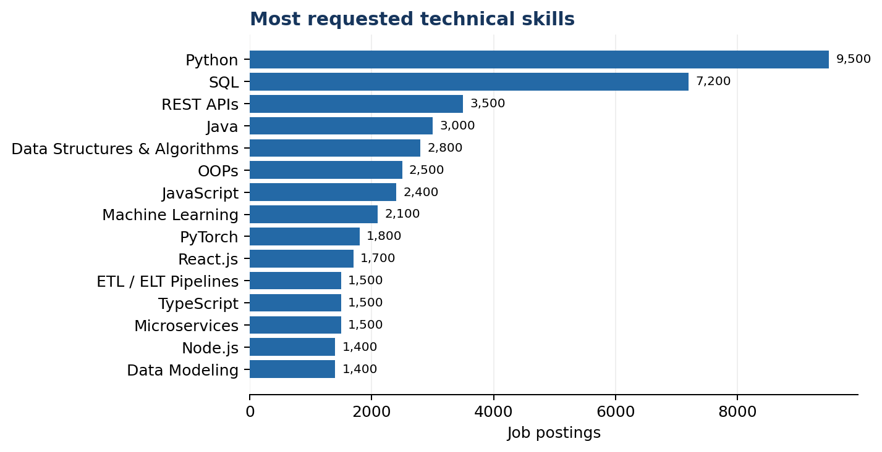
Figure 5. Top technical skills by mention count in postings.
Python leads with about 9.5K mentions and SQL follows with 7.2K. REST APIs (3.5K), Java (3.0K), Data Structures & Algorithms (2.8K), OOPs (2.5K) and JavaScript (2.4K) form the next group. Python and SQL are therefore the clearest foundational priorities across the postings represented in this dashboard.
The counts are mentions recorded in postings, not a guarantee that every employer tests a skill in the same way. They should be used as indicators of recurring demand rather than as an exact measure of proficiency required.

5.2 Development & Data Skills Analysis
Skill area | Dashboard examples | Practical implication for candidates
Programming fundamentals | Python, Java, JavaScript, OOPs | Practise writing readable code and explaining core concepts.
Problem solving | Data Structures & Algorithms | Build confidence with arrays, strings, searching, sorting and complexity basics.
Backend and integration | REST APIs, Microservices, Node.js | Understand HTTP methods, API requests/responses and basic service design.
Data and databases | SQL, Data Modeling, ETL/ELT Pipelines | Practise joins, aggregations, schema design and simple data workflows.
AI and machine learning | Machine Learning, PyTorch | Create reproducible projects and understand model evaluation.
Frontend development | React.js, TypeScript | Learn component-based UI concepts and typed JavaScript.
The dashboard spans software development, data engineering, analytics and AI. A fresher should first choose a target role family, then build a coherent project stack instead of treating every skill in the top-15 list as equally urgent.

5.3 Tools Analysis
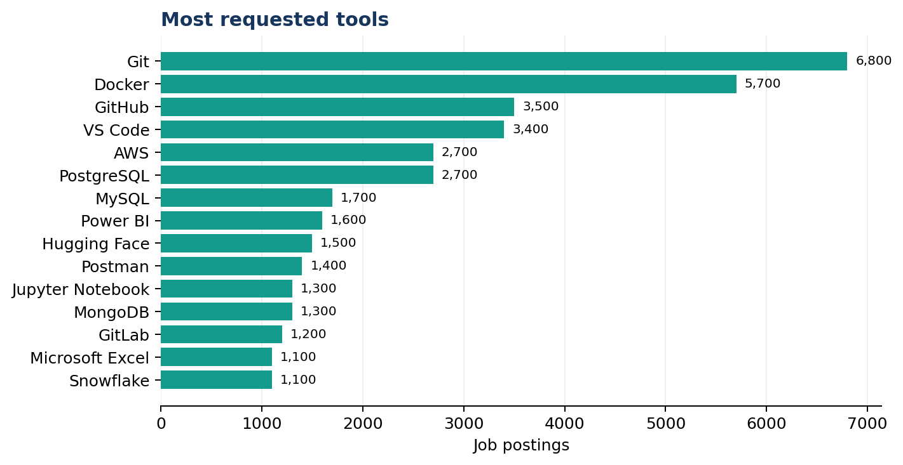
Figure 6. Top tools by mention count in postings.
Git (6.8K) and Docker (5.7K) are the most frequently mentioned tools. GitHub (3.5K) and VS Code (3.4K) support the common development workflow. AWS and PostgreSQL each appear at about 2.7K mentions. Other tools include MySQL, Power BI, Hugging Face, Postman, Jupyter Notebook, MongoDB, GitLab, Microsoft Excel and Snowflake.
Tool cluster | Tools from the dashboard | Suggested practice
Version control | Git, GitHub, GitLab | Commit changes, use branches and maintain a clear project repository.
Containers and development | Docker, VS Code | Run a small application in a container and document setup steps.
Cloud | AWS | Understand core cloud concepts and deploy a small demonstration project.
Databases | PostgreSQL, MySQL, MongoDB, Snowflake | Write queries and explain when relational or document storage is suitable.
API testing | Postman | Test endpoints, status codes, request bodies and response data.
Analytics and AI | Power BI, Excel, Jupyter Notebook, Hugging Face | Build a dashboard or notebook with reproducible analysis.

5.4 Departments Hiring Freshers
Department label | Share of labelled postings
Software Engineering | 22.39%
Core Engineering | 20.10%
Application Development | 19.78%
AI & Machine Learning | 10.84%
AI/ML | about 7.05%
Generative AI | 6.95%
Next-Gen AI Engineering | 6.52%
Big Data & Analytics | 6.37%
Department labels are present for 6.891K postings, approximately 58% of the total dataset. Software Engineering, Core Engineering and Application Development together account for about 62% of this labelled subset. The AI-related labels add up to about 31%, but “AI/ML” and “AI & Machine Learning” are separate dashboard categories and may overlap conceptually.

5.5 Fresher Hiring & Experience Expectations
The dashboard uses several experience labels, including 0–2 years, 1–2 years, Fresher (0 years) and 0–1 year. Because these bands overlap, they should not be interpreted as distinct groups. The practical conclusion is that candidates should apply to roles that accept up to two years of experience when the job description permits fresh graduates, while checking each employer’s eligibility criteria.
- Keep a role-specific resume and link to demonstrable projects.
- Describe internships, academic projects and practical work honestly.
- Read required versus preferred skills carefully before applying.
- Prepare to explain fundamentals and the decisions made in projects.

5.6 Employer and Source Platform Analysis
Startups and foreign multinationals are tied as the largest company types, each with about 3.4K postings (around 29%). Mid-size IT services and consulting firms contribute about 2.8K (24%), while product-based companies contribute about 1.6K (14%). This distribution supports searching across company sizes and business models.
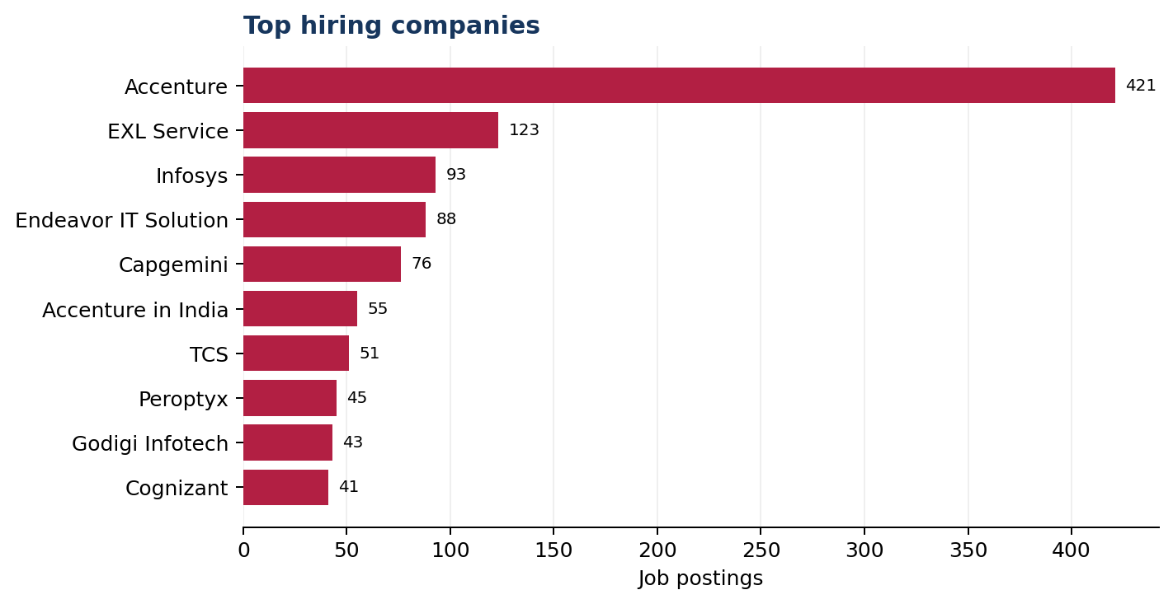
Figure 7. Top hiring companies by posting count.
Accenture leads the company chart with 421 postings. EXL Service has 123, Infosys 93, Endeavor IT Solution 88 and Capgemini 76. “Accenture in India” is a separate label with 55 postings; combining these labels would yield 476 postings, but the dashboard currently keeps them separate. The top ten entries together account for about 1,036 postings, roughly 9% of the market.
Source platform | Postings (approx.)
Glassdoor | 2.9K
Indeed India | 2.4K
Naukri.com | 2.2K
Shine.com | 1.5K
LinkedIn | 1.4K
Greenhouse | 0.4K
Ashby | 0.3K
Instahyre | 0.3K
Workable | 0.2K
Lever | 0.1K
The five general job boards supply approximately 88% of the data. Company applicant-tracking boards such as Greenhouse, Ashby, Workable and Lever contribute a smaller combined number of postings. Candidates can use both large job boards and employer career pages to broaden their search.

6. Salary Analysis

6.1 Salary Overview
The dashboard reports an average advertised salary of 7.43 LPA. This should be treated as a summary of the salary values available in the dataset, not as a guaranteed offer for a fresher. The dashboard does not display the number of postings contributing to the average, so the coverage of salary data cannot be confirmed from the current visual alone.

6.2 Salary by Role
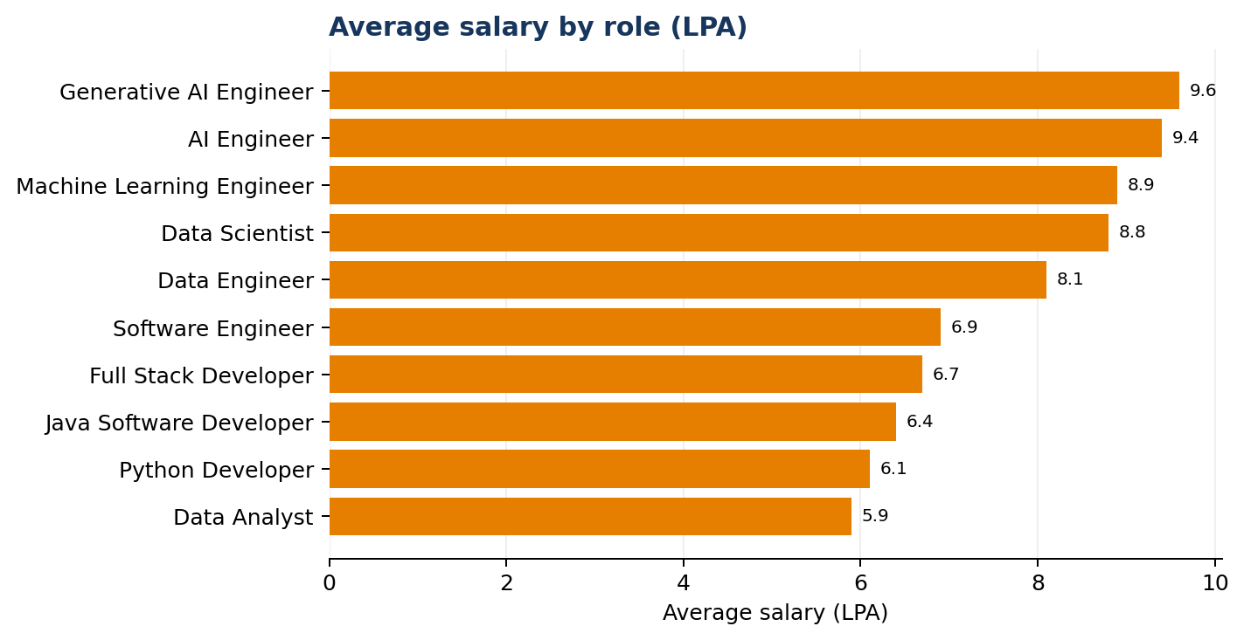
Figure 8. Average advertised salary by role (LPA).
Generative AI Engineer has the highest displayed average among the roles shown at 9.6 LPA, followed by AI Engineer (9.4), Machine Learning Engineer (8.9), Data Scientist (8.8) and Data Engineer (8.1). Software Engineer is shown at 6.9, Full Stack Software Developer at 6.7, Java Software Developer at 6.4, Python Developer at 6.1 and Data Analyst at 5.9 LPA.
The gap between the highest and lowest roles shown is 3.7 LPA. This comparison suggests that specialisation can be associated with different advertised salary levels, but it does not prove that choosing a particular technology alone causes higher pay. Location, company, role scope, experience and the subset of postings reporting salary may also affect the averages.

6.3 Salary by Experience
Experience label | Average salary (LPA)
1–2 years | 8.1
0–2 years | 7.4
0–1 year | 6.9
Fresher (0 years) | 6.6
The displayed average for the 1–2 years band is about 1.5 LPA higher than the true-fresher band, approximately 23% more. Since the experience categories overlap, this comparison should be read as dashboard-labelled groups rather than independent, mutually exclusive cohorts.

6.4 Salary by City
City | Average salary (LPA)
Gurugram | 8.0
Bengaluru | 7.9
Hyderabad | 7.8
Mumbai | 7.7
Noida | 7.5
New Delhi | 7.5
Chennai | 7.4
Pune | 7.4
Kolkata | 6.6
Ahmedabad | 6.4
Gurugram has the highest displayed city average at 8.0 LPA, just ahead of Bengaluru at 7.9 and Hyderabad at 7.8. Kolkata and Ahmedabad are lowest among the cities listed. The city spread is about 1.6 LPA, smaller than the 3.7 LPA difference across the roles shown.

6.5 Highest-Paying Tech Roles
The highest displayed averages belong to Generative AI Engineer, AI Engineer, Machine Learning Engineer, Data Scientist and Data Engineer. These roles may involve specialised knowledge, but candidates should select a path based on interest, foundational readiness and the requirements in actual job descriptions rather than salary alone.

6.6 Salary by Job Role and Career Path
Career path | Skills/tools visible in dashboard | Salary signal shown
AI / Generative AI | Python, Machine Learning, PyTorch, Hugging Face | AI Engineer 9.4 LPA; Generative AI Engineer 9.6 LPA
Data Science | Python, SQL, Machine Learning, Jupyter Notebook | Data Scientist 8.8 LPA
Data Engineering | SQL, ETL/ELT, Data Modeling, databases, AWS | Data Engineer 8.1 LPA
Software development | Java, JavaScript, REST APIs, OOPs, Git, Docker | Software Engineer 6.9; Full Stack 6.7 LPA
Data analytics | SQL, Python, Power BI, Excel | Data Analyst 5.9 LPA
The dashboard’s salary comparisons are descriptive and depend on the quality and coverage of salary records. They should support career exploration, not be treated as a salary guarantee or a formal compensation benchmark.

7. Key Business & Career Insights
- The market is fragmented: 5,538 companies contribute 11,781 postings, and the top ten company entries represent only about 9% of postings.
- Software development, data engineering, data science and AI are prominent role families in the fresher dataset.
- Python and SQL are the strongest cross-role skill signals; Git and Docker are the leading tool mentions.
- The experience labels suggest that candidates should not search only for postings explicitly labelled “Fresher”; many postings accept 0–2 years.
- Bengaluru, Mumbai, Hyderabad and Chennai have high posting volumes, while Pune is also a significant location.
- On-site remains the largest work mode, but remote and hybrid together represent more than half of the displayed distribution.
- AI and data-specialist titles have higher displayed average salaries than several general software and analyst titles.
- Data quality issues, including inconsistent state values, overlapping experience labels and missing salary coverage, should be addressed before stronger conclusions are drawn.

8. Recommendations

8.1 For Students / Freshers
- Build a strong foundation in Python and SQL before adding multiple specialised technologies.
- Practise Git and GitHub, and gain basic Docker familiarity for collaborative development workflows.
- Choose a target track—software development, data engineering, analytics, data science or AI—and complete at least one end-to-end project relevant to it.
- For software roles, strengthen data structures, algorithms, OOP and API fundamentals. For data roles, practise SQL, data modelling and ETL/ELT concepts.
- Apply to suitable 0–2 year roles as well as explicitly labelled fresher roles; verify each job’s actual eligibility criteria.
- Search across Bengaluru, Mumbai, Hyderabad, Chennai and Pune, and consider hybrid and remote roles where eligible.
- Use salary comparisons as guidance only; prioritise role fit, learning opportunities and the quality of the job description.

8.2 For Training Institutions
- Align practical training with frequently mentioned skills and tools in the dashboard.
- Use role-based learning paths rather than one broad curriculum for all technology careers.
- Include Git-based teamwork, API testing, database work and project documentation in hands-on assignments.
- Teach students to interpret job descriptions and distinguish required skills from preferred skills.
- Track changes in job-posting demand and refresh training content periodically.

8.3 For ACC
- Use the dashboard to support evidence-based career guidance and fresher skill-roadmap design.
- Create focused learning pathways for software development, data engineering, analytics and AI/ML roles.
- Help candidates build demonstrable projects that align with Python, SQL, Git, Docker and the chosen role-specific stack.
- Improve data quality by standardising locations, merging duplicate company/category labels and creating non-overlapping experience bands.
- Add the number of postings with valid salary data and make missing-value coverage visible in the dashboard.
- Label estimated chart values and ensure all charts show readable values and definitions.

9. Conclusion
The Freshers Tech Job Market Analysis Dashboard shows a broad entry-level technology market with opportunities spread across thousands of employers and hundreds of cities. Software Engineer and Full Stack Software Developer are the most common titles shown, while data and AI roles also feature prominently. Python, SQL, Git and Docker emerge as key foundational skills and tools in the dataset.
The dashboard also indicates that many postings accept some prior experience, making projects, internships and practical evidence important for fresh graduates. Major hiring centres include Bengaluru, Mumbai, Hyderabad, Chennai and Pune, while work arrangements span on-site, hybrid and remote roles. Salary averages vary by job family, with AI and data-specialist titles showing higher displayed values in this dataset.
For students, the most useful approach is to build fundamentals, select a target role family, develop practical projects and apply broadly to eligible roles. For training institutions and ACC, the findings can guide curriculum and career support, provided that the dashboard’s data-quality limitations are addressed.

Appendix: Data Notes & Caveats
The following limitations are visible in the supplied dashboard and should be considered when interpreting the report.
Observation | Impact / recommended action
Bengaluru posting count is not directly labelled on the funnel chart. | The report describes it as approximately 2.0K based on the visible funnel marker. Add a direct data label.
Hiring States KPI shows 91 values. | This suggests inconsistent state/location values or non-Indian locations. Standardise state and country fields.
A company located in Ireland appears in the top-company list. | Review geography filters and confirm whether the report is intended to cover India-only postings.
Work Modes KPI shows 4, while the donut shows 3 named modes. | The donut totals about 11.688K rather than 11,781; inspect blank/other categories.
Department data covers about 6.891K postings (58%). | Department shares describe the labelled subset only. Show coverage and missing values.
Company and department labels contain near-duplicates. | Merge labels such as Accenture / Accenture in India only after validating entity identity.
Experience bands overlap. | Re-bucket into mutually exclusive ranges before calculating share totals.
Some source and industry labels are truncated. | Widen visuals, add tooltips or provide a detailed data table.
Average salary lacks a displayed record count. | Add the number and percentage of postings with valid salary data and verify units.
Skill/tool values are mention counts. | Document the extraction method and avoid treating mentions as unique candidates or guaranteed requirements.
Source: Power BI dashboard supplied for the Freshers Tech Job Market project. Figures are reported as shown or rounded; estimates and data-quality caveats are identified in the relevant sections.

